PROCLAMATION
WHEREAS, the Mayor of the City of Columbus, Ohio, has the authority to recognize occasions of outstanding significance; and
WHEREAS, in the digital age, educational outcomes and economic mobility are tied directly to the ability to get online; and
WHEREAS, neighborhoods across the nation are experiencing a digital divide; and
WHEREAS, the COVID-19 health crisis has shed light on the need for home internet service, and the large number of American households in all kinds of communities who do not have it; and
WHEREAS, Digital Inclusion Week 2021 is sponsored by the National Digital Inclusion Alliance, representing more than 600 affiliated organizations working together to reach our common goal: that all people have access and use of the Internet and the tools they need to use it; and
WHEREAS, Digital Inclusion Week 2021 aims to raise awareness of solutions addressing home internet access, personal devices, and local technology training and support programs.
NOW, THEREFORE, I, Andrew J. Ginther, Mayor of the City of Columbus, Ohio, do hereby proclaim October 4th-October 8th as:

Digital Inclusion Week 2021
and urge all residents of Columbus to join in recognition of this significant occasion.

IN WITNESS WHEREOF, I have hereunto set my hand and caused the Great Seal of the Mayor of the City of Columbus, Ohio, to be hereto affixed this 4th day of October, 2021.

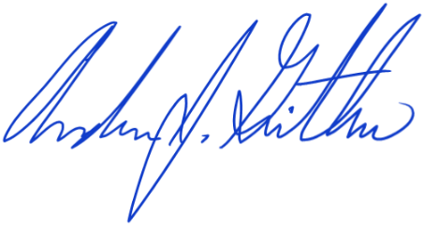
____________________________
Andrew J. Ginther
Mayor

