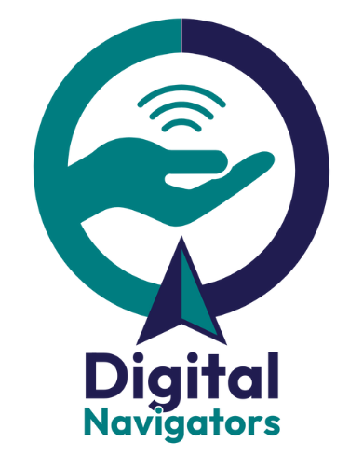
What do digital navigators do?

Digital navigators consistently provide holistic,
individualized support through repeated interactions.

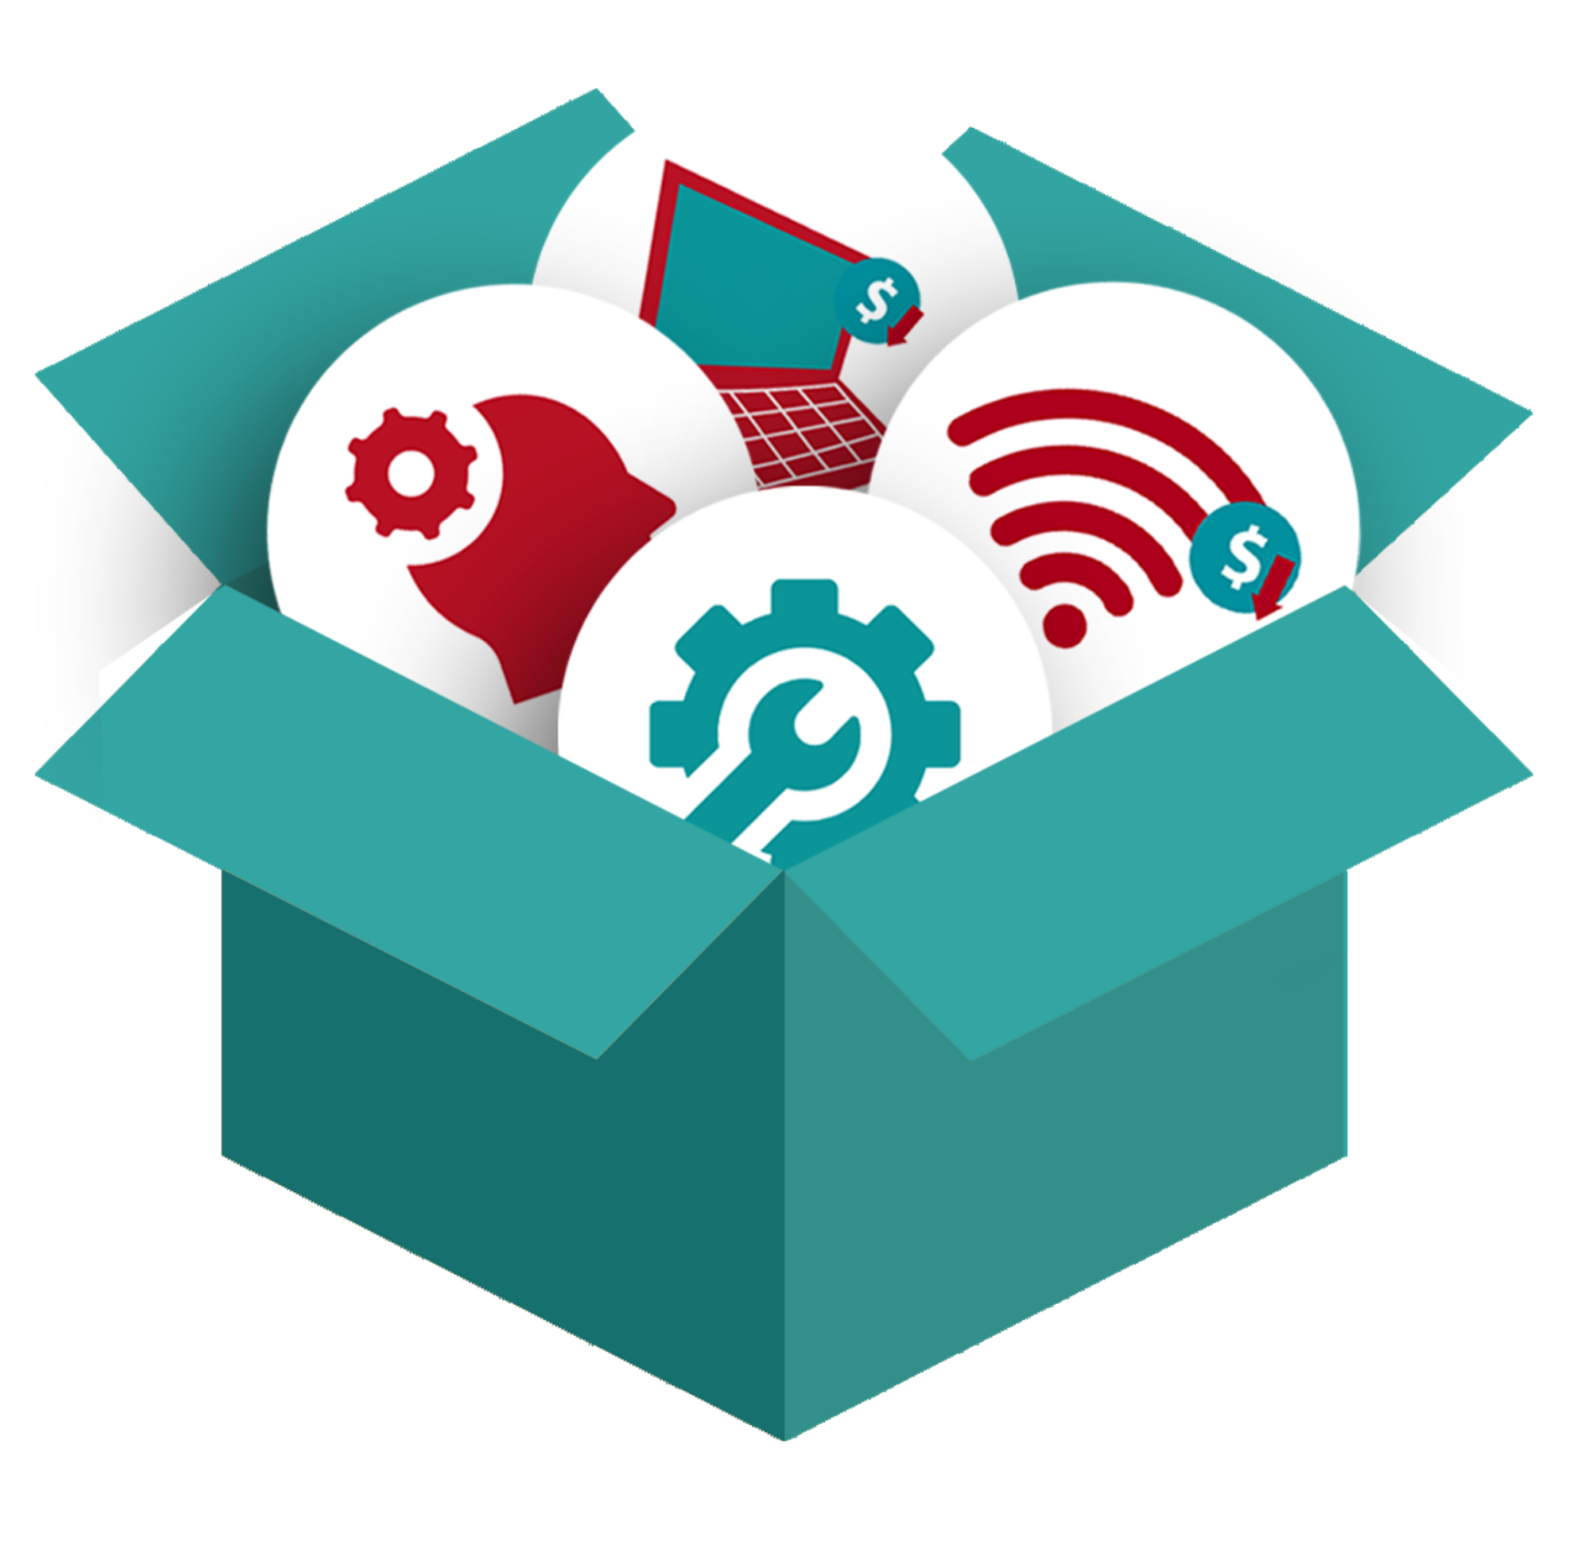
“Holistic support” means digital navigator services include all the key aspects of digital inclusion, including devices, connectivity, and digital skills. The elements are interconnected.


One-on-one interactions mean community members receive individualized support to meet their personal goals however works best for them.


Repeated interactions build trust
and provide a human connection
along the entire process.

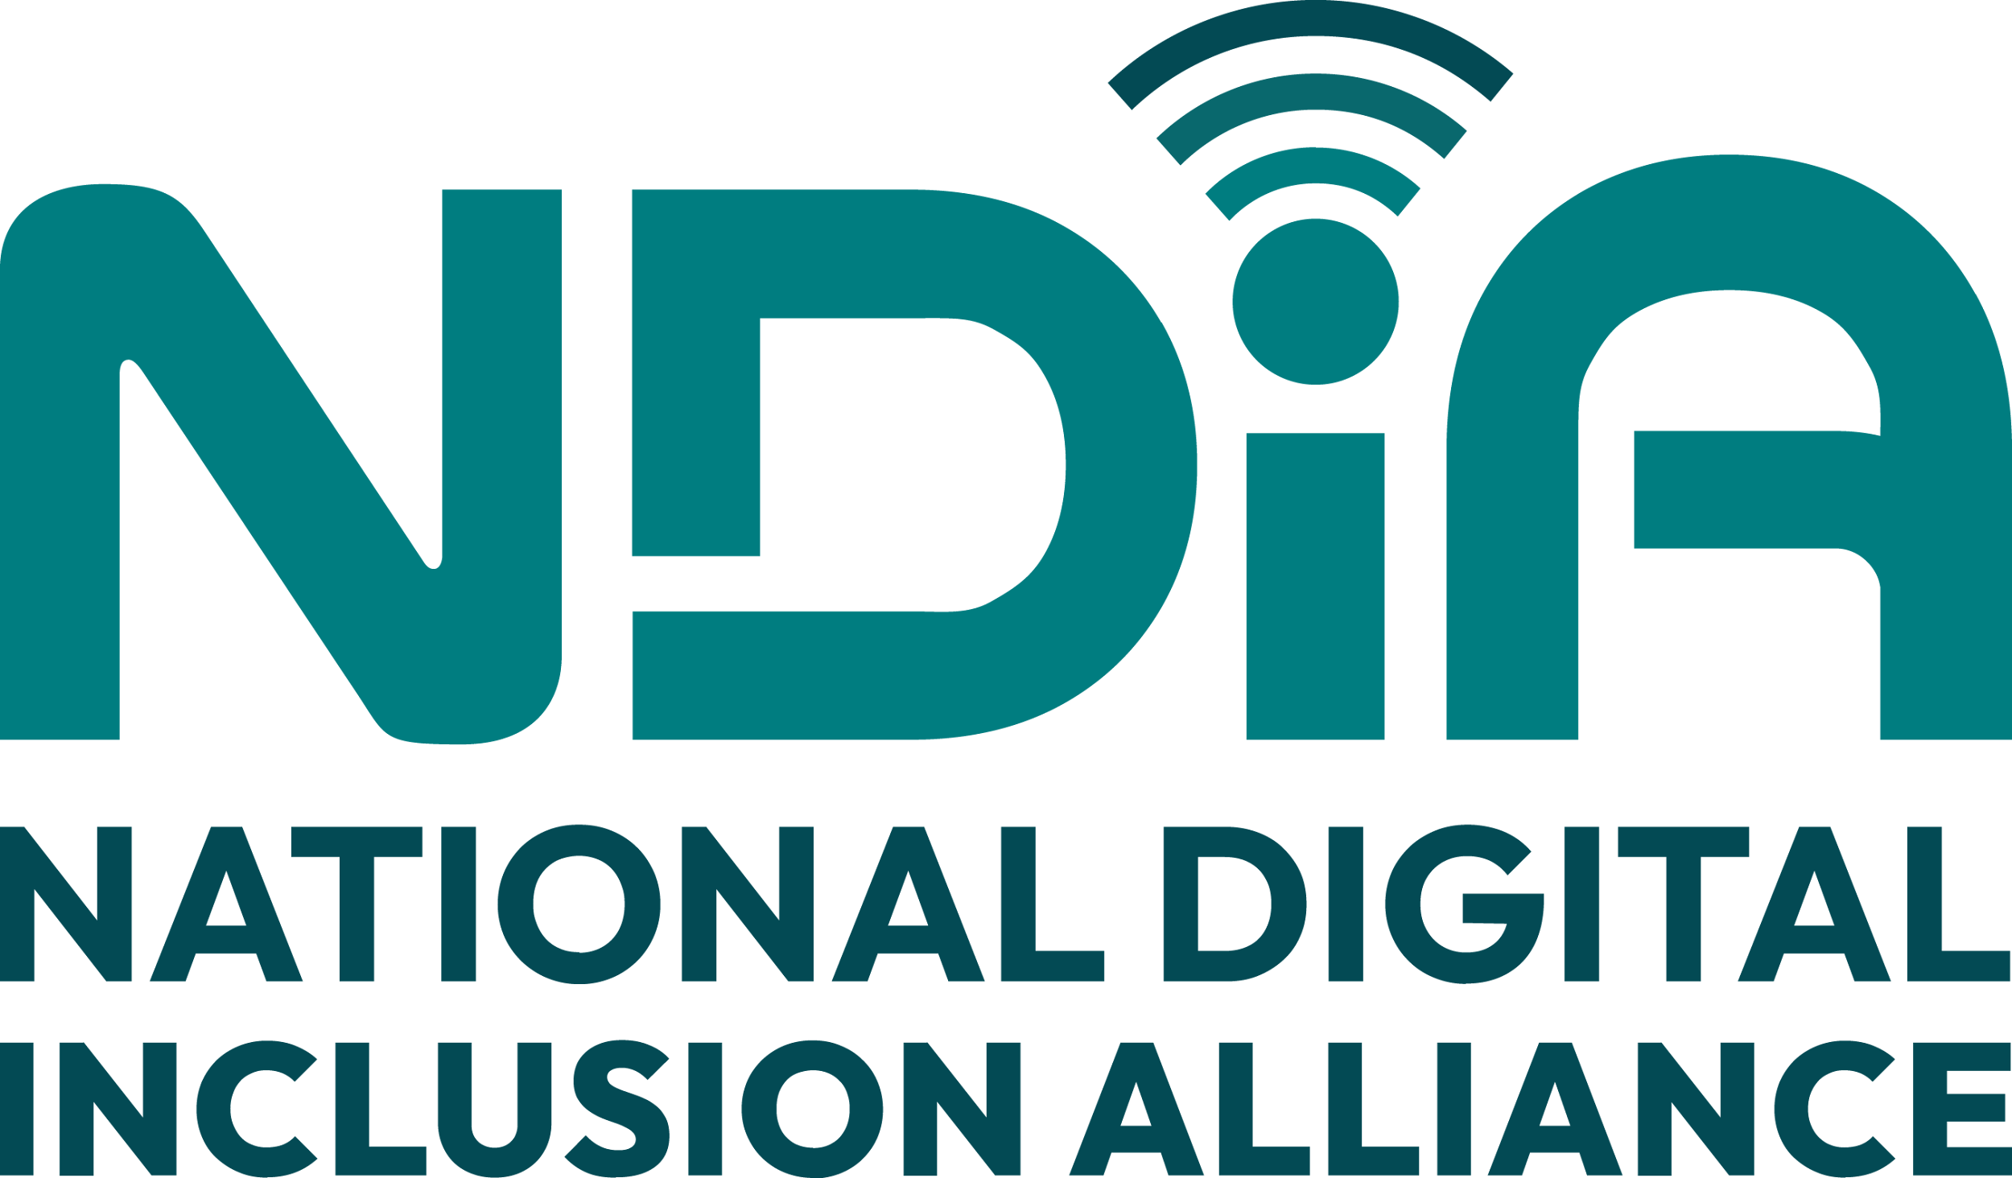
Learn more about the digital navigator model from the National Digital Inclusion Alliance and our community of affiliates at digitalinclusion.org/dn

