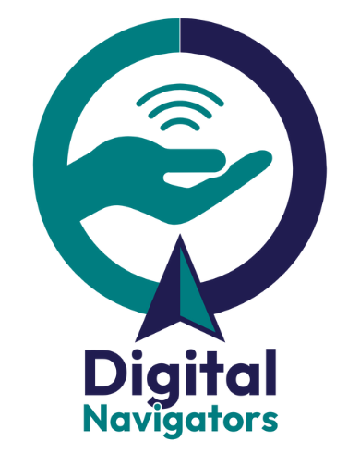
Digital Navigators
in Your Community

Digital navigators can serve anywhere that community members gather or turn to for resources.

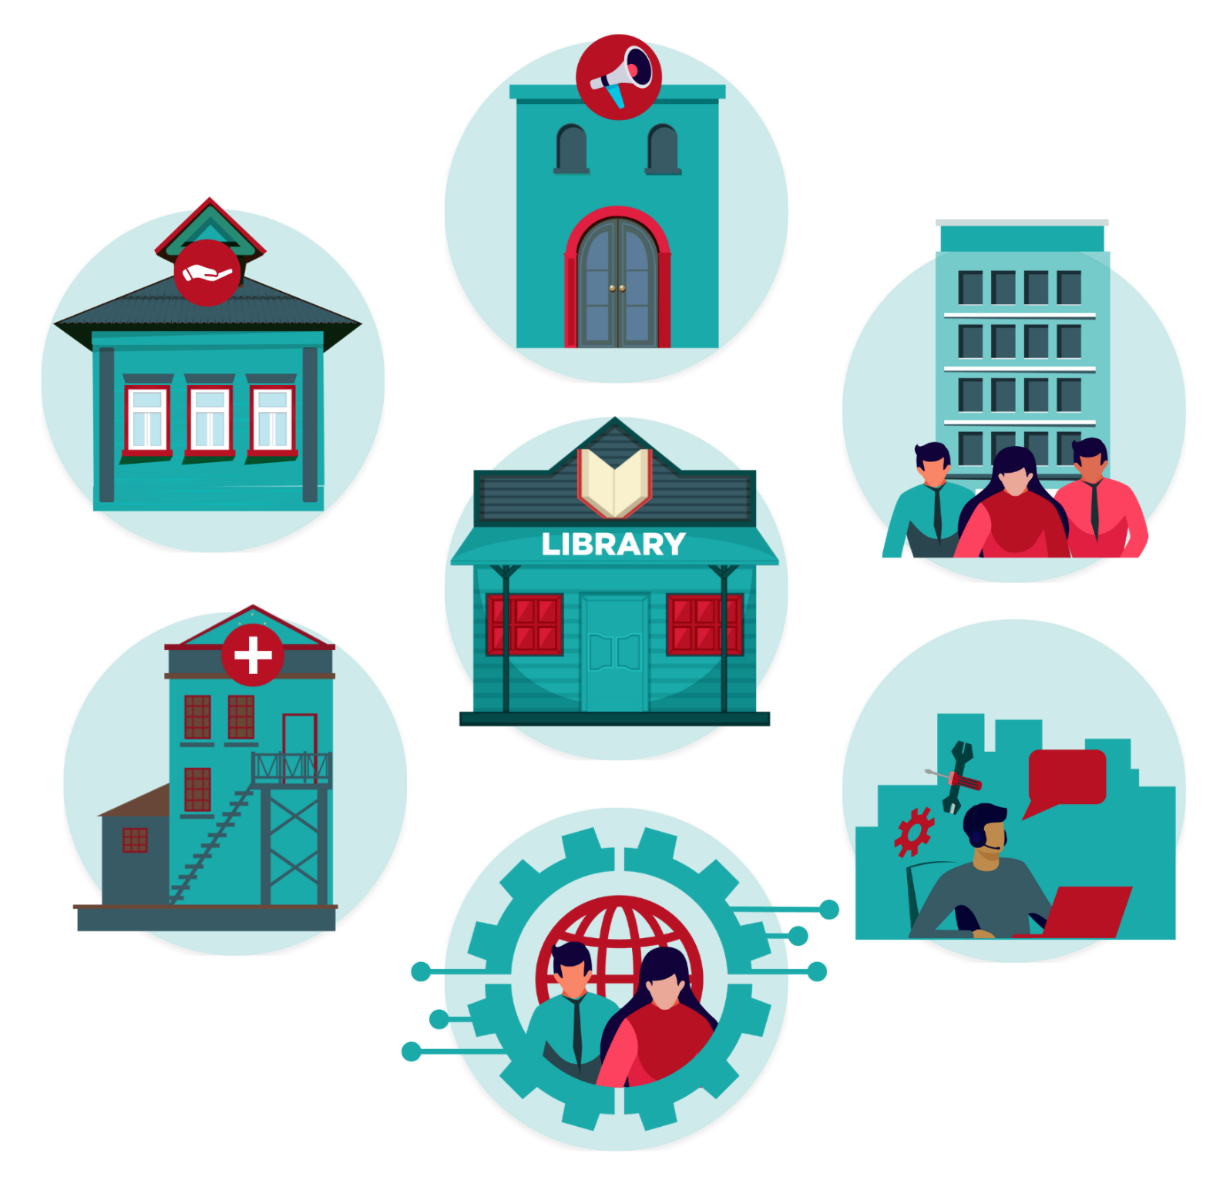
NDIA has identified digital navigators working in public and academic libraries, workforce development centers, senior centers, community centers, in city hall, community action agencies, 311 call centers, and more.

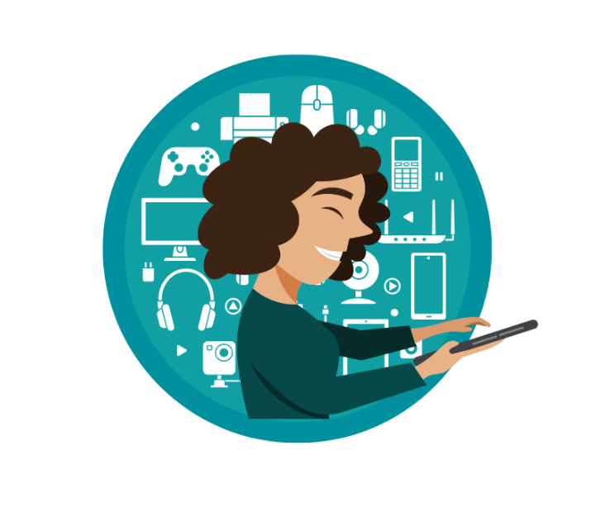
Partnerships within your community are key to digital navigator success.
Partner organizations can act as trusted messengers, provide critical resources for community member’s wellbeing, and act as a referral network.

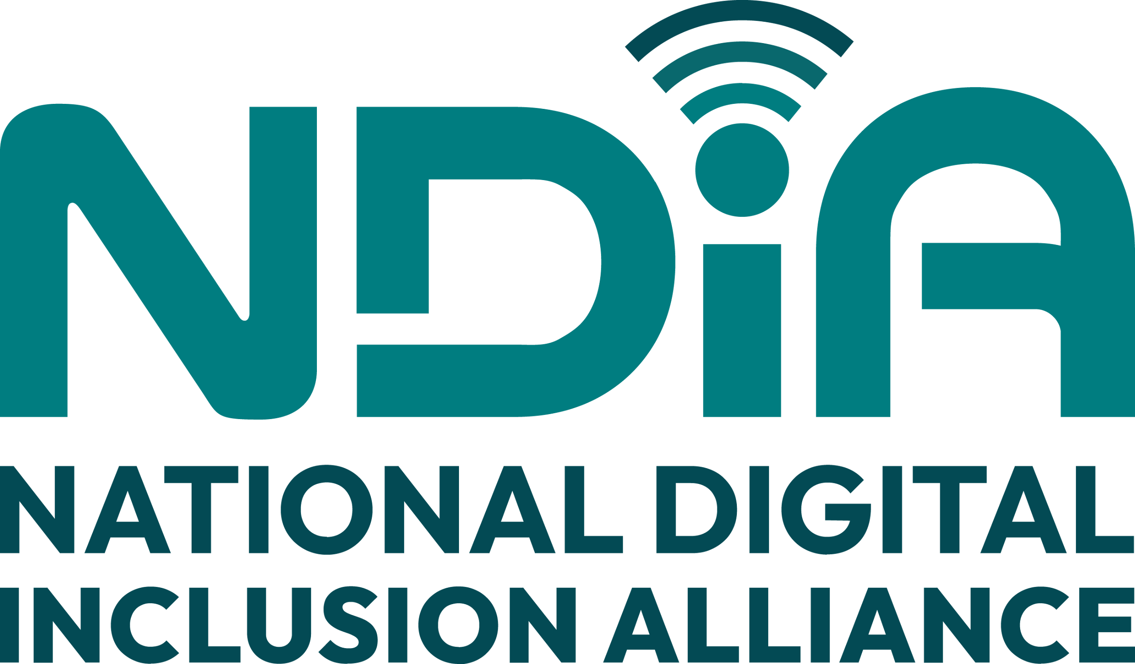
Learn more about the digital navigator model from the National Digital Inclusion Alliance and our community of affiliates at digitalinclusion.org/dn

