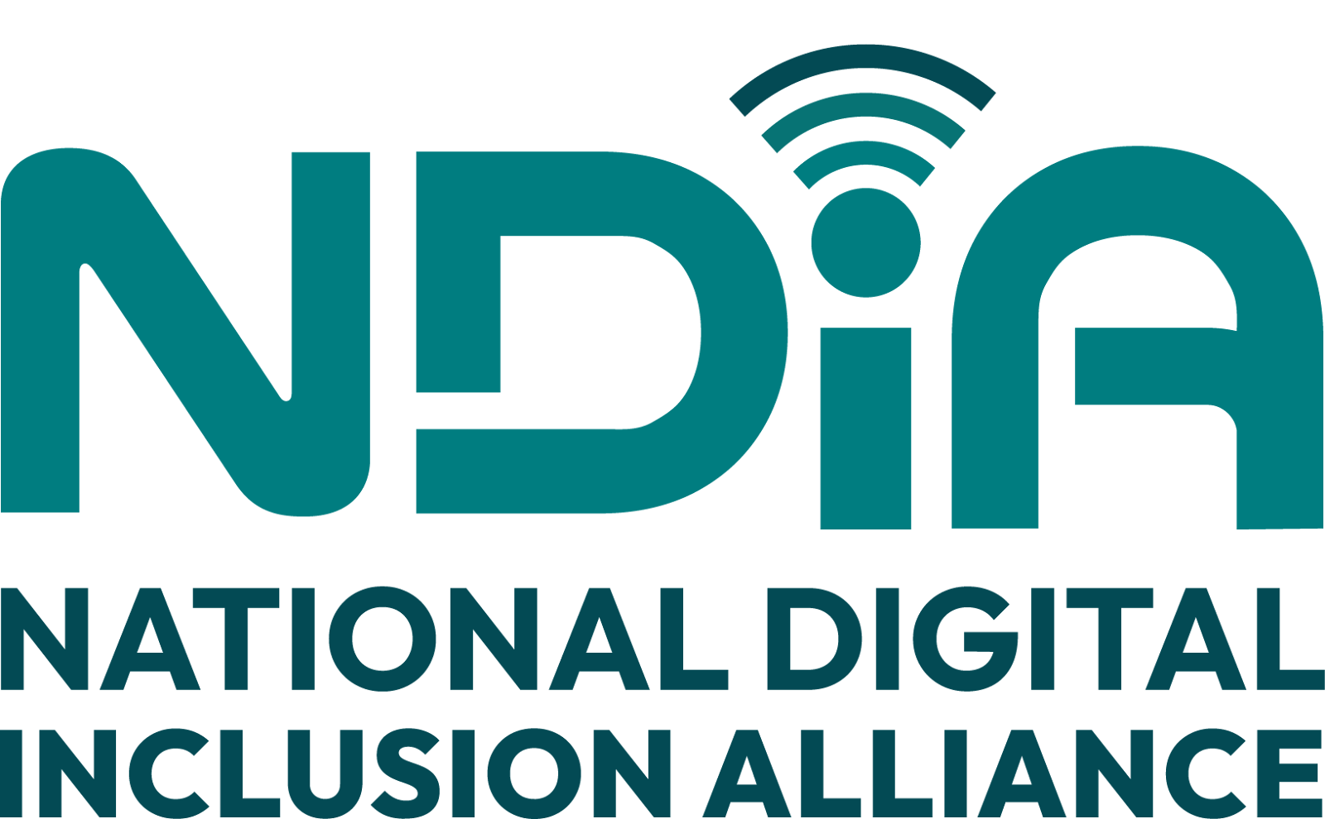

Individual & Household Technology Check-up Tool

Background for providers:

These questions provide a baseline for what information and communications technology an individual and their household have and may need. There are four sections plus a couple starting questions.

Use these as a starting guide. You may also want to ask follow-up questions to get more details on someone’s needs, including reliability and affordability of internet and devices. They may not know all the answers, especially if they rely on another person to help them with their connectivity and technology devices and set-up.
This check-up also provides an opportunity to share what assistance is available to them.

Let the community member know how you will use this completed check-up tool with them. This could also be updated with them after services are provided to identify progress and any continued needs.



Technology Check-Up

Introduction
These questions are to help you and your household learn what internet, computer, or mobile device set-up and support you and your household have and what you may need. Please feel free to ask if you don’t understand a question or to skip it for now. You are also welcome to share any additional information not asked for that you think may be helpful.

Starting questions

- How much of an internet user are you now (regular, sometimes, starting or don’t use)? This will help us understand and respect where you’re starting from as we ask these questions.

Regular user | Use sometimes | Starting user | Don’t use

- How many people are in your household? This will help us figure out if you have enough devices and good enough internet for what you want to do.

# of adults | # ages 5-17

Devices

- Do you currently have a computer, smartphone or tablet computer (such as ipad or chromebook) to use? Is this yours or shared?
Device | Yes/no | Number of devices | Shared with others in your household? | Brand & model | Approximately how old is it? | Owned or borrowed
Mobile phone/ smartphone
Desktop computer
Laptop
Tablet

Internet Connections

- What internet service do you use for your mobile device(s)?

- Do you have a separate internet connection in your home?

5a. Is it wired or wireless to your house (an antenna or hotspot device)?

- How adequate is the internet speed and connection where you live; is it good enough to allow you to do what you need to on the internet?
Completely Adequate | Mostly Adequate | Sometimes Adequate | Rarely Adequate | Not Adequate

- Approximately how much you pay for internet and who provides it?

7a. Is this different for mobile service or home connection?

7b. Do you have ongoing service or pay as you go services and are you able to maintain it?
7c. Do you have a package where your internet subscription includes other things like phone?

- Are you aware of or use Lifeline to help lower cost or other low-cost internet service offerings?

- Do you connect to the internet at home using a wireless Wi-Fi connection?

9a. If yes, is the connection strong enough to connect wherever you and other household members need it in your home?

9b. Do you have any devices (repeaters or mesh devices) to extend the Wi-Fi signal strength?

Monitors, Printers, Accessories

- Screen size: Do you have access to a monitor or device with a screen large enough to do all the tasks you need to do (e.g. homework, write documents, fill out forms)?
- Microphone/headset/earbuds and camera: Do you have what you need for video conferencing on your devices (a camera plus audio speakers, microphone or headset/earbuds)?
- Printer: Do you have access to a printer or need one?

- Keyboard and mice: Do you have or need an external keyboard, mouse, or trackpad?

- Assistive technology: Do you or any members of your household sharing your devices need assistive technology to help with movement, sound and visuals (such as screen readers, text or speech settings, screen enlargement, adaptive keyboard or trackball)?

- Back-up storage: Do you have an external hard drive or use an online cloud service such as Google Drive, One Drive, Dropbox or ICloud to back up your files?

- Protection: Do you have security and anti-virus protection running on your devices?

Tech support
- What tech support do you have for help with your internet and your computers or phones, if any?

- Do you need support to:
  - Install software and apps, including privacy, anti-virus, and security tools?
  - Set up your devices and accounts and manage privacy and security settings?
  - Use email and find what you need online?

Closing question: Anything to add?

- Do you have anything additional to share about your needs for internet, devices, set-up or support?

